**SQL-Assignment-3**

**Name: PATEL DEV V.**

* **Create Database:**

**CREATE** DATABASE WorkDB;

USE WorkDB;

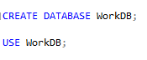

* **Create Table:**

**QUERY**:

* **DEPARTMENT TABLE**

CREATE TABLE Department (

dept_id INT PRIMARY KEY,

dept_name NVARCHAR(50) NOT NULL

)

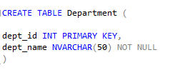

* **EMPLOYEE TABLE**

CREATE TABLE Employee (

emp_id INT PRIMARY KEY,

dept_id INT NOT NULL ,

mngr_id INT ,

emp_name NVARCHAR(50) NOT NULL,

salary MONEY ,

FOREIGN KEY (dept_id) REFERENCES Department (dept_id)

)

* **INSERTING VALUES IN DEPARTMENT TABLE:**

INSERT INTO Department(dept_id, dept_name )

VALUES(1001, 'FINANCE')

INSERT INTO Department(dept_id, dept_name )

VALUES(2001 ,'AUDIT')

INSERT INTO Department(dept_id, dept_name )

VALUES(3001 , 'marketing')

INSERT INTO Department(dept_id, dept_name )

VALUES(4001 , 'production')

* **INSERTING VALUES IN EMPLOYEE TABLE:**

INSERT INTO Employee (emp_id,dept_id,mngr_id,emp_name,salary)

VALUES (501,1001,NULL,'Krish',60000)

INSERT INTO Employee (emp_id,dept_id,mngr_id,emp_name,salary)

VALUES (502,3001,501,'Brijesh',27500)

INSERT INTO Employee (emp_id,dept_id,mngr_id,emp_name,salary)

VALUES (503,1001,501,'Chandu',25500)

INSERT INTO Employee (emp_id,dept_id,mngr_id,emp_name,salary)

VALUES (504,2001,501,'Jay',29570)

INSERT INTO Employee (emp_id,dept_id,mngr_id,emp_name,salary)

VALUES (505,2001,504,'Suresh',31000)

INSERT INTO Employee (emp_id,dept_id,mngr_id,emp_name,salary)

VALUES (506,2001,504,'Feni',31000)

INSERT INTO Employee (emp_id,dept_id,mngr_id,emp_name,salary)

VALUES (507,2001,506,'Sanket',9000)

INSERT INTO Employee (emp_id,dept_id,mngr_id,emp_name,salary)

VALUES (508,3001,502,'Aayush',17000)

INSERT INTO Employee (emp_id,dept_id,mngr_id,emp_name,salary)

VALUES (509,3001,502,'Bablu',13500)

INSERT INTO Employee (emp_id,dept_id,mngr_id,emp_name,salary)

VALUES (510,3001,502,'Madden',13500)

INSERT INTO Employee (emp_id,dept_id,mngr_id,emp_name,salary)

VALUES (511,3001,502,'Taksh',16000)

INSERT INTO Employee (emp_id,dept_id,mngr_id,emp_name,salary)

VALUES (512,2001,505,'Aesha',12000)

INSERT INTO Employee (emp_id,dept_id,mngr_id,emp_name,salary)

VALUES (513,3001,502,'Juli',10500)

INSERT INTO Employee (emp_id,dept_id,mngr_id,emp_name,salary)

VALUES (514,1001,503,'Moksh',14000)

INSERT INTO Employee (emp_id,dept_id,mngr_id,emp_name,salary)

VALUES (515,1001,501,'Chako',25000)

* **VIEWING DATA IN TABLE**

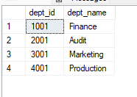

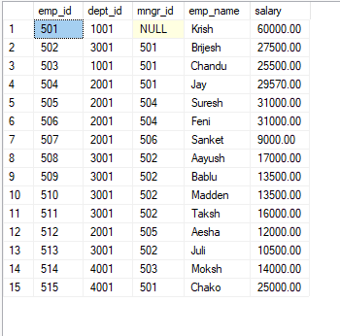

**1. write a SQL query to find Employees who have the biggest salary in their Department**

**QUERY:**

SELECT DISTINCT E.Emp_id, E.Emp_name, D.Dept_id, D.Dept_name, E.Salary

FROM Employee E

Inner Join Department D

ON D.Dept_id = E.Dept_id,

(SELECT K.Dept_id,MAX(Salary) AS 'MAXSAL'

FROM Employee K

Group By Dept_id) Y

WHERE E.Dept_id=Y.Dept_id AND E.Salary = Y.MAXSAL

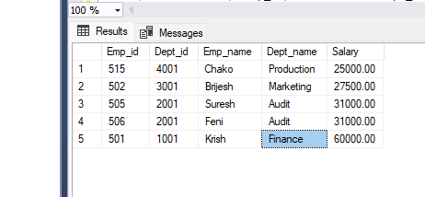

**2. write a SQL query to find Departments that have less than 3 people in it**

**QUERY:**

SELECT D.dept_name, D.dept_id , Y.Total AS "Total Employee"

FROM ( SELECT COUNT(E.emp_id) AS Total , E.dept_id

FROM Employee E

GROUP BY (E.dept_id)

HAVING COUNT(E.dept_id) < 3) Y

INNER JOIN Department D ON Y.dept_id = D.dept_id

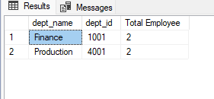

**3. write a SQL query to find All Department along with the number of people there**

**QUERY:**

SELECT Y.dept_id , D.dept_name ,Y.Total AS "Total Employee"

FROM(SELECT E.dept_id , COUNT(E.emp_id) AS Total

FROM Employee E

GROUP BY E.dept_id ) Y

INNER JOIN Department D ON Y.dept_id = D.dept_id

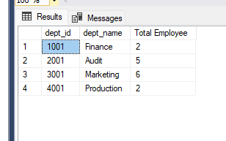

**4. write a SQL query to find All Department along with the total salary there.**

**QUERY:**

SELECT Y.dept_id, D.dept_name,Y.Total_Salary

FROM(SELECT E.dept_id , SUM(E.salary) AS 'Total_Salary'

FROM Employee E

GROUP BY E.dept_id ) Y

INNER JOIN Department D ON Y.dept_id=D.dept_id

